E.G.S.PILLAY ENGINEERING COLLEGE, NAGAPATTINAM
DEPARTMENT OF MCA
MC7404-NETWORK PROGRAMMING
CYCLE TEST-1 KEY DATE: 26.02.2016
UNIT 1-PART-A
- Describe layered model of TCP/IP protocol.( May/June 2013)
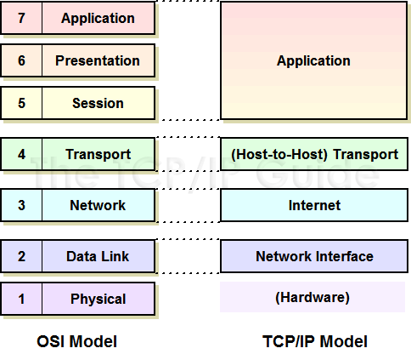
- Difference between move and copy a file(August 2013)
Cp old_filename destination_filename- a copy of the file will be moved to the destination, source remains in same place.
Mv old_file new_file- there won’t be any copy at the source , it is completely moved to destination file.
- Compare signals and interrupts in UNIX.( May/June 2014)
Signals are software interrupts. Most nontrivial application programs need to deal with signals.
Signals provide a way of handling asynchronous events: a user at a terminal typing the interrupt key
to stop a program or the next program in a pipeline terminating prematurely.
- What are the common shells in use in UNIX system? How does the system decide which shell is to be executed? May/June 2015)
A shell is a command-line interpreter that reads user input and executes commands. The user input to a shell is normally from the terminal (an interactive shell) or sometimes from a file (called a shell script).
- Bourne shell
- Bourne-again shell
- C shell
- Korn shell
- TENEX C shell
The system knows which shell to execute for us from the final field in our entry in the password file.
- What is socket? ( May/June 2013,2014)
A socket is one endpoint of a two-way communication link between two programs running on the network. A socket is bound to a port number so that the TCP layer can identify the application that data is destined to be sent to.
An endpoint is a combination of an IP address and a port number. Every TCP connection can be uniquely identified by its two endpoints. That way you can have multiple connections between your host and the server.
- What is the purpose of concurrent server? .( May/June 2013)
concurrent server, one that handles multiple clients at the same time. The simplest
technique for a concurrent server is to call the Unix fork function (Section 4.7), creating
one child process for each client.
- The INADDR-ANY & INADDR-BROADCAST constants defined by <netinet/in.h> header are in host byte order. Justify the statement. ( May/June 2015)
With IPv4, the wildcard address is specified by the constant INADDR_ANY, whose value is normally 0. This tells the kernel to choose the IP address.
The value of INADDR_ANY (0) is the same in either network or host byte order, so the use of htonl is not really required. But, since all the INADDR_constants defined by the <netinet/in.h> header are defined in host byte order, we should use htonl with any of these constants.
- List the eight ways of process termination. ( Feb/March 2014)
1. Return from main
2. Calling exit
3. Calling _exit or _Exit
4. Return of the last thread from its start routine
5. Calling pthread_exit from the last thread
Abnormal termination occurs in three ways:
6. Calling abort
7. Receipt of a signal
8. Response of the last thread to a cancellation request.
- Define reliable signal. ( Feb/March 2014)
signal is generated for a process (or sent to a process) when the event that causes the signal occurs. The event could be a hardware exception (e.g., divide by 0), a software condition (e.g., an alarm timer expiring), a terminal-generated signal, or a call to the kill function. When the signal is generated, the kernel usually sets a flag of some form in the process table.

PART-B
11 a. Write a detailed note on TCP Protocol.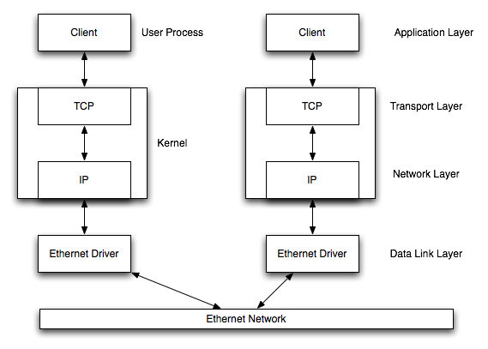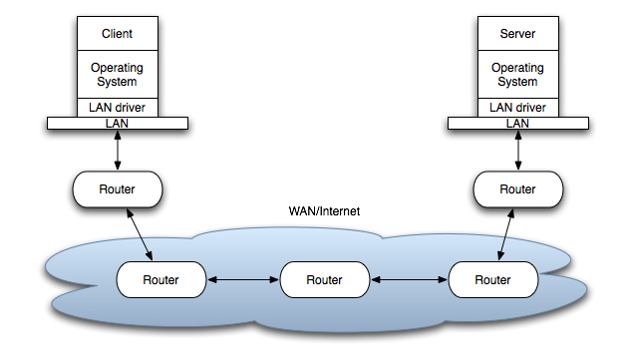

.
11. b.How do you establish Interprocess communication in UNIX? Give example
Introduction
Pipes: A pipe is created by calling the pipe function.
#include <unistd.h>
int pipe(int filedes[2]);
Returns: 0 if OK, 1 on error
Coprocesses:
A UNIX system filter is a program that reads from standard input and writes to standard output. Filters are normally connected linearly in shell pipelines. A filter becomes a coprocess when the same program generates the filter's input and reads the filter's output. The Korn shell provides coprocesses [Bolsky and Korn 1995].
FIFOs:
FIFOs are sometimes called named pipes. Pipes can be used only between related processes when a common ancestor has created the pipe. Creating a FIFO is similar to creating a file. Indeed, the pathname for a FIFO exists in the file system.
Semaphores:
A semaphore is a counter used to provide access to a shared data object for multiple processes. The Single UNIX Specification includes an alternate set of semaphore interfaces in the semaphore option of its real-time extensions. We do not discuss these interfaces in this text. To obtain a shared resource, a process needs to do the following:
Shared Memory:
struct shmid_ds {
struct ipc_perm shm_perm; /* see Section 15.6.2 */
size_t shm_segsz; /* size of segment in bytes */
pid_t shm_lpid; /* pid of last shmop() */
pid_t shm_cpid; /* pid of creator */
shmatt_t shm_nattch; /* number of current attaches */
time_t shm_atime; /* last-attach time */
time_t shm_dtime; /* last-detach time */
time_t shm_ctime; /* last-change time */ };
The first function called is usually shmget, to obtain a shared memory identifier.
#include <sys/shm.h>
int shmget(key_t key, size_t size, int flag);
Returns: shared memory ID if OK, 1 on error

12.b.What are the different file types available in UNIX? Explain with example.(Feb/march 2014)
- Regular file.
- Directory file
- Block special file.
- Character special file.
- FIFO.
- Socket.
- Symbolic link.
- File type

12.a. Write about files and directories in Unix
stat, fstat, and lstat Functions
#include <sys/stat.h>
int stat(const char *restrict pathname, struct
stat *restrict buf);
int fstat(int filedes, struct stat *buf);
int lstat(const char *restrict pathname, struct
stat *restrict buf);
All three return: 0 if OK, 1 on error
Set-User-ID and Set-Group-ID
- real user ID,real group ID :who we really are
- effective user ID , effective group ID, supplementary group IDs: used for file access permission , checks
File Access Permissions
st_mode mask Meaning
S_IRUSR user-read
S_IWUSR user-write
S_IXUSR userexecute
Ownership of New Files and Directories: implementation to choose one of the following options to determine the group ID of a new file.
- The group ID of a new file can be the effective group ID of the process.
- The group ID of a new file can be the group ID of the directory in which the file is being created. The Linux ext2 and ext3 file systems allow the choice between these two POSIX.1 options
access Function: The access function bases its tests on the real user and group IDs.
#include <unistd.h>
int access(const char *pathname, int mode);
Returns: 0 if OK, 1 on error
Symbolic Links
13.b.Explain architecture of unix in details.(Aug 2011)
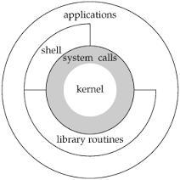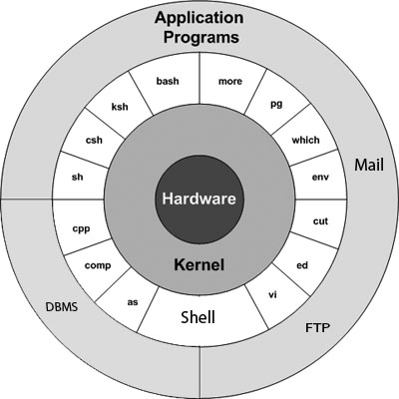
It is responsible for scheduling running of user and other processes. It is responsible for allocating memory. It is responsible for managing the swapping between memory and disk. It is responsible for moving data to and from the peripherals. It receives service requests from the processes and honours them.
14.a. Explain the socket address structure.
Socket Address Structures
Most socket functions require a pointer to a socket address structure as an argument. Each
supported protocol suite defines its own socket address structure. The names of these structures
begin with sockaddr_ and end with a unique suffix for each protocol suite.
IPv4 Socket Address Structure
An IPv4 socket address structure, commonly called an "Internet socket address structure," is
named sockaddr_in and is defined by including the <netinet/in.h> header. Figure 3.1 shows the
POSIX definition.
Generic Socket Address Structure
struct sockaddr {
uint8_t sa_len;
sa_family_t sa_family; /* address family: AF_xxx value */
char sa_data[14]; /* protocol-specific address */
};
New Generic Socket Address Structure
- B.Explain the following function in socket programming. (i) connect () (ii) bind() (iii) listen() (iv) socket() (v) accept().( May/June 2014)
- socket Function
#include <sys/socket.h>
int socket (int family, int type, int protocol);
Returns: non-negative descriptor if OK, -1 on error
- connect Function
#include <sys/socket.h>
int connect(int sockfd, const struct sockaddr *servaddr, socklen_t addrlen);
Returns: 0 if OK, -1 on error
(iii) bind Function
#include <sys/socket.h>
int bind (int sockfd, const struct sockaddr *myaddr, socklen_t addrlen);
Returns: 0 if OK,-1 on error
- listen Function
#include <sys/socket.h>
#int listen (int sockfd, int backlog);
Returns: 0 if OK, -1 on error
- accept Function
#include <sys/socket.h>
int accept (int sockfd, struct sockaddr *cliaddr, socklen_t *addrlen);
Returns: non-negative descriptor if OK, -1 on error
15.a.Explain the steps involved in terminal login.(Feb/March 2014)
  - BSD Terminal Logins
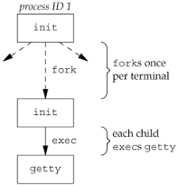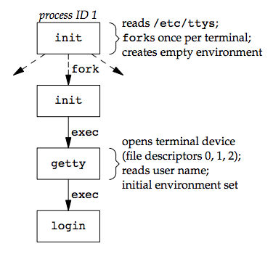
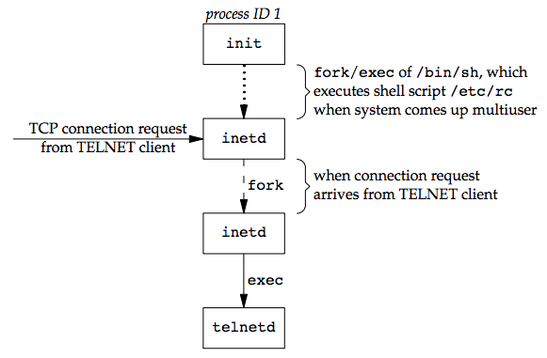
- B. Write short on address conversion function.
inet_aton, inet_addr, and inet_ntoa Functions
#include <arpa/inet.h>
int inet_aton(const char *strptr, struct in_addr *addrptr);
Returns: 1 if string was valid, 0 on error
in_addr_t inet_addr(const char *strptr);
Returns: 32-bit binary network byte ordered IPv4 address; INADDR_NONE if error
char *inet_ntoa(struct in_addr inaddr);
Returns: pointer to dotted-decimal string
